CIRCULAR ECONOMY
A circular economy is an economic system that tackles global challenges like climate change, biodiversity loss, waste, and pollution by reusing, sharing, repairing, refurbishing, remanufacturing and recycling to create a closed-loop system, minimizing the use of resource inputs and the creation of waste, pollution and carbon emissions. The circular economy aims to keep products, materials, equipment and infrastructure in use for longer, thus improving the productivity of these resources.
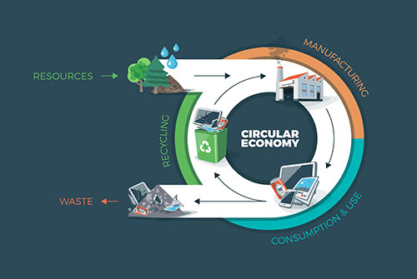
The principles of circular economy:
- Design out waste and pollution
- Keep products and materials in use
- Regenerate natural systems

Benefits of the circular economy:
- Fewer Greenhouse Gas Emissions
- Healthy And Resilient Soils
- Fewer Negative Externalities
- Increased Potential for Economic Growth
- More Resources Saved
- Employment Growth
- New Profit Opportunities
- Volatility Reduction and Safeguarded Supplies
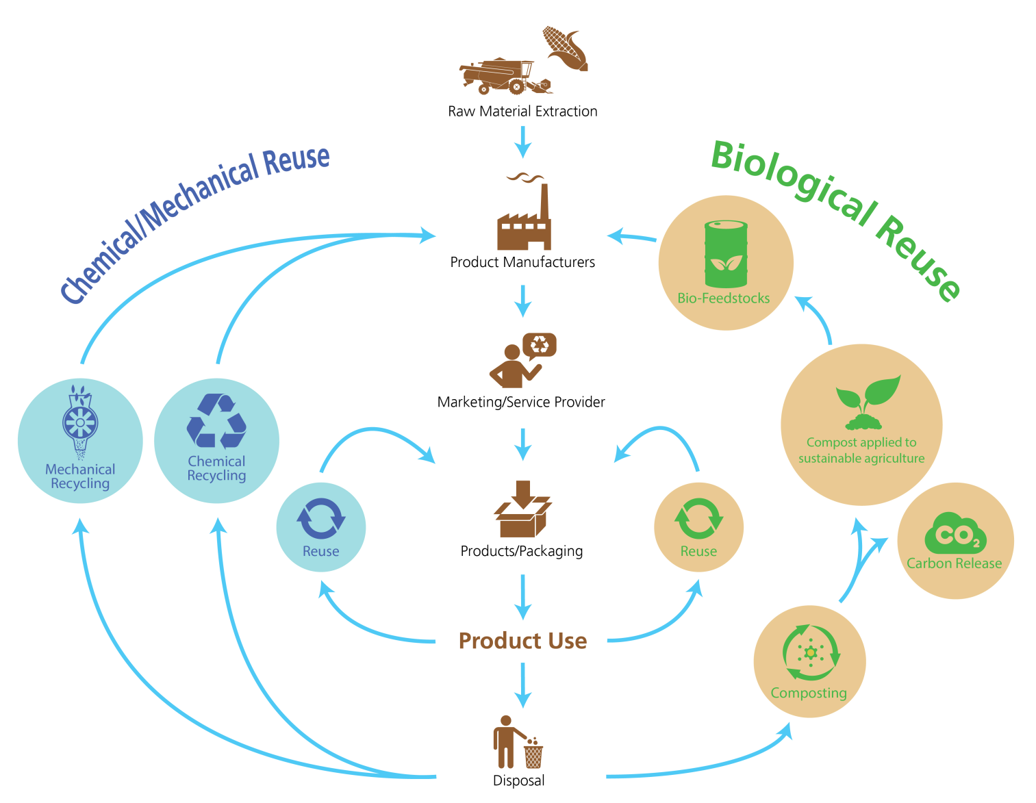
Barriers To a Circular Economy Model:
- Social and environmental externalities are not considered in prices, privileging financial market signals instead of people and nature when economic decisions are made;
- Prices of raw materials are fickle and at low prices alternative, good quality secondary resources are not competitive;
- Circular economy business models are harder to develop, as most investors are still working under a linear economy logic and sometimes upfront investments are required;
- The demand for circular products and alternatives is still small;
- New business models may be challenging to implement and develop because of laws and regulations that aren’t prepared for this kind of innovations.
Circular economy for food
A circular economy for food mimics natural systems of regeneration so that waste does not exist, but is instead feedstock for another cycle.
In a circular economy, organic resources such as those from food by-products, are free from contaminants and can safely be returned to the soil in the form of organic fertiliser. Some of these by-products can provide additional value before this happens by creating new food products, fabrics for the fashion industry, or as sources of bioenergy. These cycles regenerate living systems, such as soil, which provide renewable resources, and support biodiversity.
Creating such a systemic shift will require investments of both time and funding, but without either, our agricultural systems are on a trajectory to suffer in the long-term, which will impact all of us.
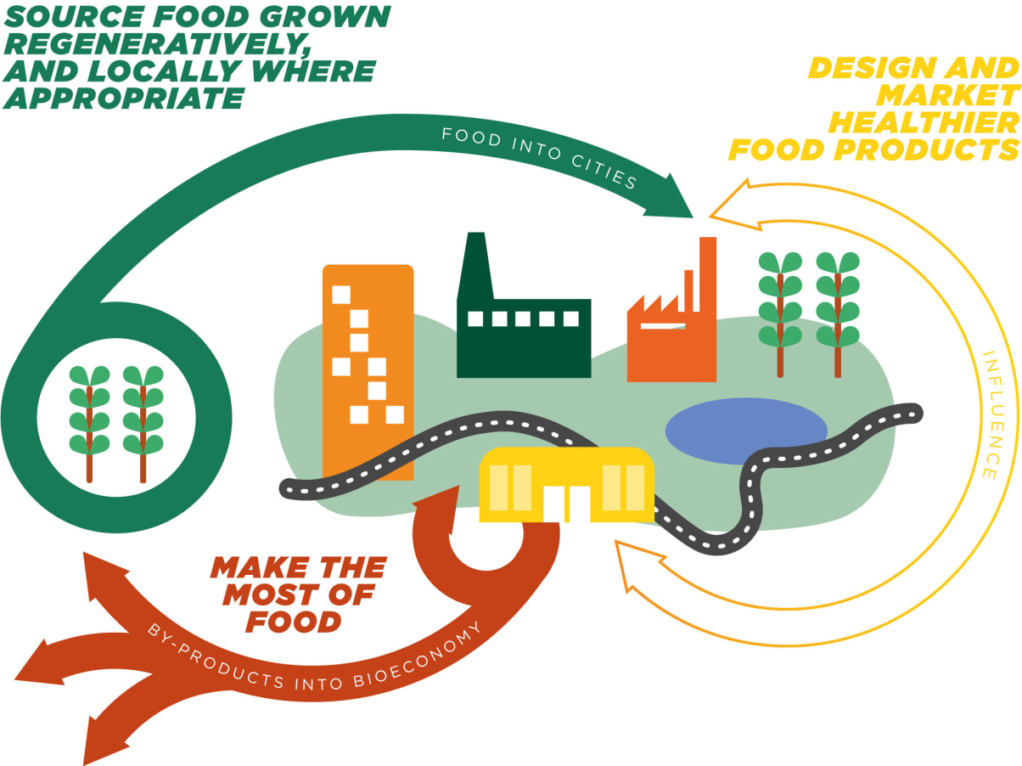
Regenerative approaches to food production will ensure the food that enters cities is cultivated in a way that enhances rather than degrades the environment. In this context, regenerative food production means to encompass production techniques that improve the overall health of the ecosystem.
Currently, a third of all food produced globally – worth USD 1 trillion – is thrown away each year. This represents a huge loss of nutrients and a major cause of environmental issues. Yet, still, 10% of the global population continues to go hungry.
In a circular economy, food is designed to cycle, so the by-products from one enterprise provides input for the next. Cities can make the most of food by redistributing surplus edible food, while turning the remaining inedible by-products into new products, ranging from organic fertilisers for regenerative peri-urban farming, to biomaterials, medicine, and bioenergy.
Food products must be designed through a system that provides healthy production as well as nutrition.
Types of economy
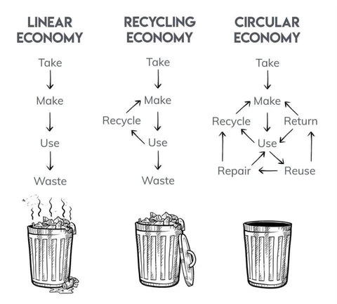

Bibliography:
- https://en.wikipedia.org/wiki/Circular_economy
- https://youmatter.world/en/definition/definitions-circular-economy-meaning-definition-benefits-barriers/
- https://www.ellenmacarthurfoundation.org/explore/food-cities-the-circular-economy
- https://circulesolutions.com/circular-packaging/?gclid=Cj0KCQjwl_SHBhCQARIsAFIFRVVVwEm9-s-itS0RXc3Ek5sgaKTliWgy2YjCVHPDn9UgAOAAHweGsEoaAlB-EALw_wcB
- https://kenniskaarten.hetgroenebrein.nl/en/knowledge-map-circular-economy/what-is-the-definition-a-circular-economy/

